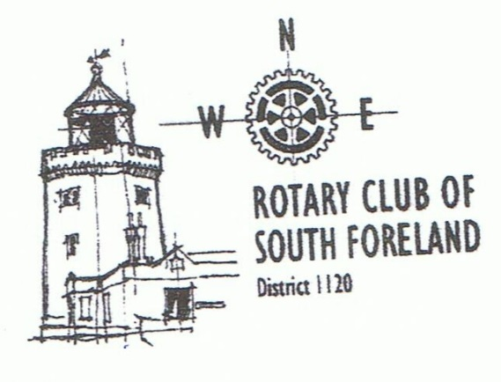

This popular annual evening organised by the Rotary Club of South Foreland includes a two-course Supper and Raffle.

7 for 7.30pm

Wednesday 8 October 2014

Cullins Yard, Dover

All for just £12.50 per person

Bookings to 01304 502172

by Monday 6 October 2014

Booking essential—vegetarians please specify in advance.

Numbers limited—First come first served

Book the date now!

ADVANCE NOTICE!