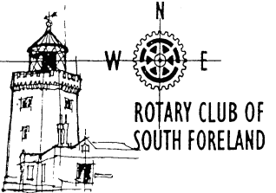



**Rotary Club of South Foreland**

Invites you to a talk by

**Hugo Vickers**

**The Ultimate Deadline**

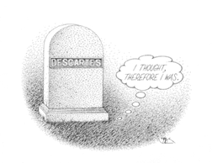

**Many of us turn to the obituary columns in our daily papers.**

**But how are these prepared and what are the subtle codes?**

**Hugo Vickers, whose first obituary was published in 1977, takes us behind the scenes in this form of journalism which bears the ultimate deadline.**

**Wednesday 12 June 2013 at 7.00 for 7.30pm**

Dover Marina Hotel and Spa

Dover Waterfront, Waterloo Crescent, Dover, CT17 9BP

**Price £15, to include dinner**

**Booking essential, by Monday 10 June by email to** [**apologies@cullinsyard.co.uk**](mailto:apologies@cullinsyard.co.uk)

**or 01304 211666**