



**Rotary Club of South Foreland**

Invites you to a talk by

**Hugo Vickers**

**Biographer and Royal Historian**

on

**Diamond Jubilee, Coronation and the Future**

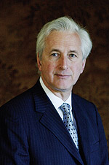

Wednesday 24 April 2013 at 7.00 for 7.30pm

Dover Marina Hotel and Spa

Dover Waterfront, Waterloo Crescent, Dover, CT17 9BP

Price £20, to include dinner

**Booking essential, by Monday 22 April by email to** [**apologies@cullinsyard.co.uk**](mailto:apologies@cullinsyard.co.uk)

**or 01304 211666**