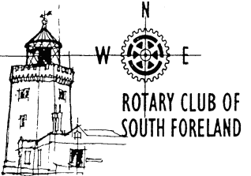



**Rotary Club of South Foreland**

Invites you to a talk by

**Graham Tutthill**

on

**A Lifetime in Local Journalism**

**On 48 years reporting in Dover – and what the future may hold**

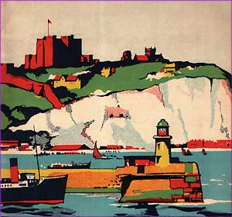 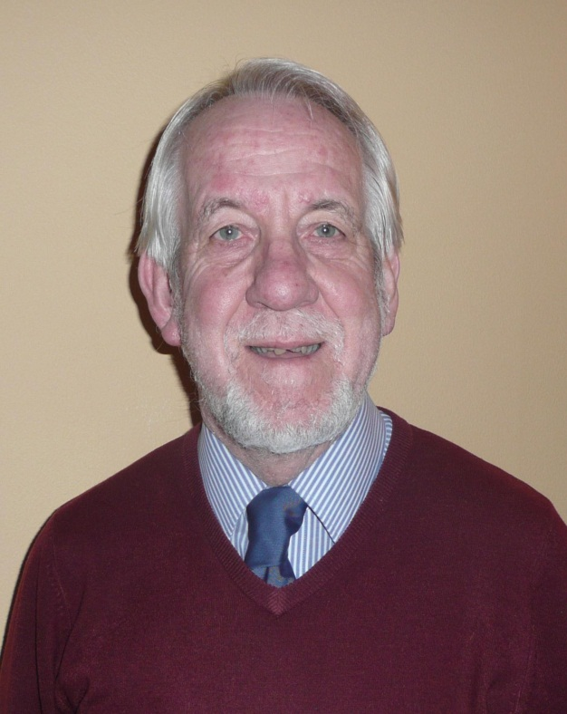

Wednesday 27 February 2013 – at 7.00 for 7.30pm

Dover Marina Hotel and Spa

Dover Waterfront, Waterloo Crescent, Dover, CT17 9BP

Price £15, to include 2-course dinner

**To book, contact apologies@cullinsyard.co.uk**